**ContractNest Second Round Of Testing-**

**QA- Nilesh Deulkar**

**Release Date-15-Jan-2026**

Modules- Contacts and Settings.

Test user- [nileshdeulkar212@gmail.com](mailto:nileshdeulkar212@gmail.com)

Password- Test@2025

**New registration: error occurs while trying to register**

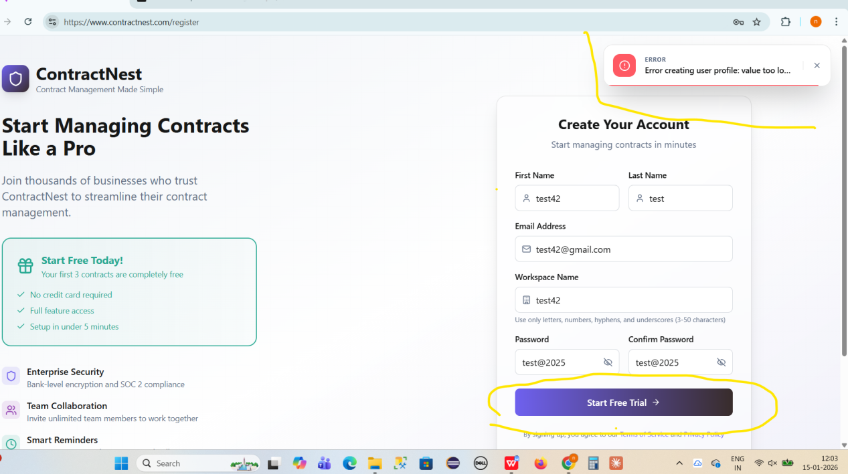

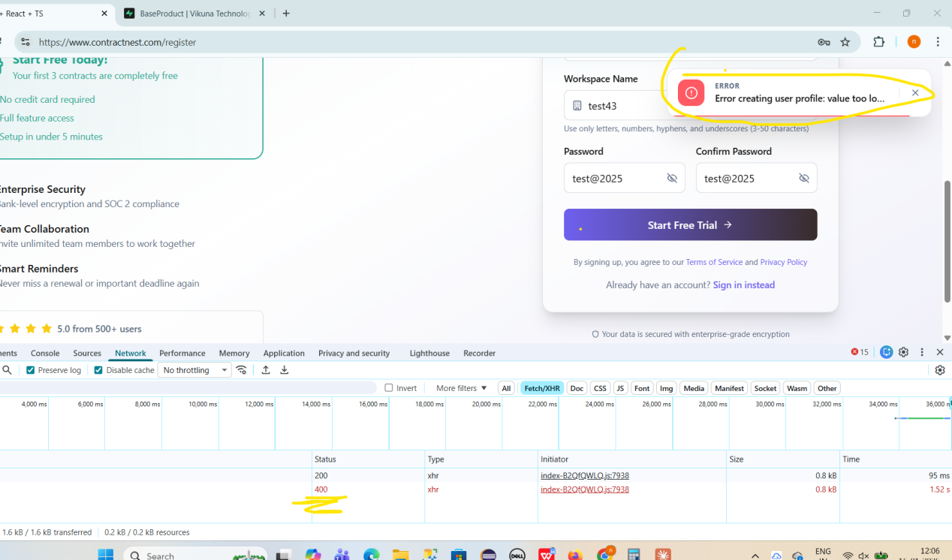

Logs----

POST https://contractnest-api-production.up.railway.app/api/auth/register 400 (Bad Request)

(anonymous) @ index-B2QfQWLQ.js:7938

apply @ index-B2QfQWLQ.js:7938

(anonymous) @ index-B2QfQWLQ.js:62

xhr @ index-B2QfQWLQ.js:62

iee @ index-B2QfQWLQ.js:64

Promise.then

_request @ index-B2QfQWLQ.js:65

request @ index-B2QfQWLQ.js:64

(anonymous) @ index-B2QfQWLQ.js:65

(anonymous) @ index-B2QfQWLQ.js:60

ae @ index-B2QfQWLQ.js:7938

$ @ index-B2QfQWLQ.js:8830

WX @ index-B2QfQWLQ.js:48

(anonymous) @ index-B2QfQWLQ.js:48

tY @ index-B2QfQWLQ.js:48

cz @ index-B2QfQWLQ.js:48

kz @ index-B2QfQWLQ.js:49

y0e @ index-B2QfQWLQ.js:49

n @ index-B2QfQWLQ.js:7938

**Onboarding Issues---**

**While updating the First Name and Last Name for a newly registered user in profile section, the system throws a “Validation Failed” error and the details are not updated.**

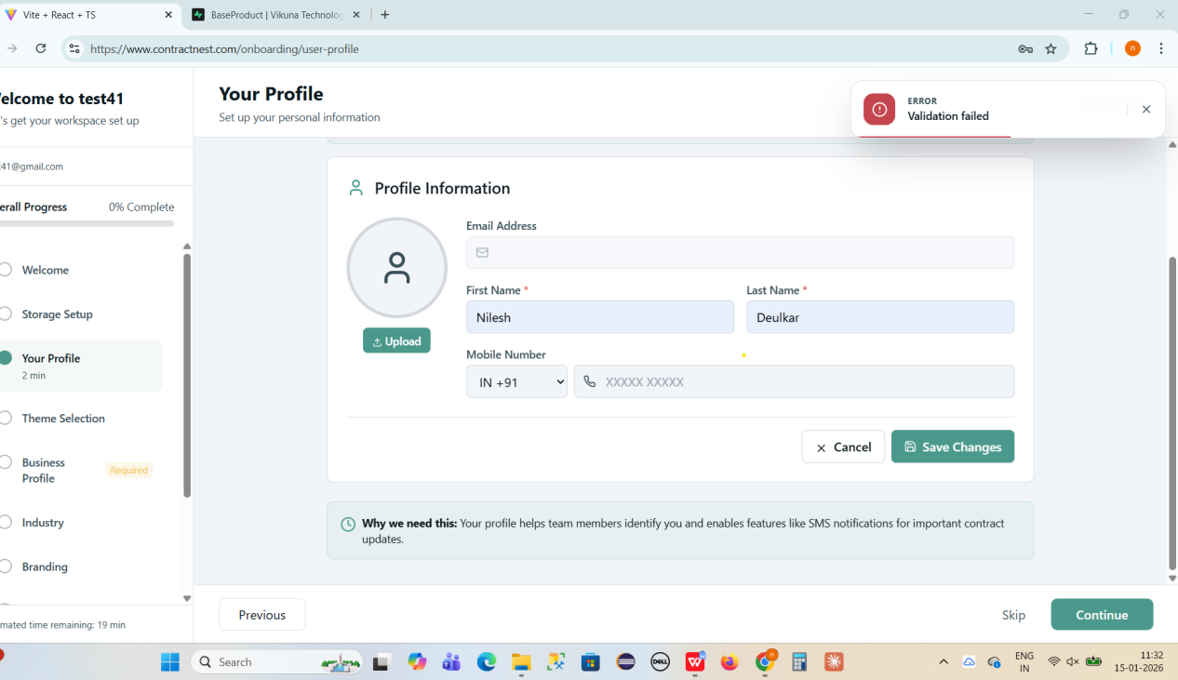

**Avatar upload is failing, but no error message is displayed and no error logs are generated in the browser and jpg file is not uploaded for old tenants** 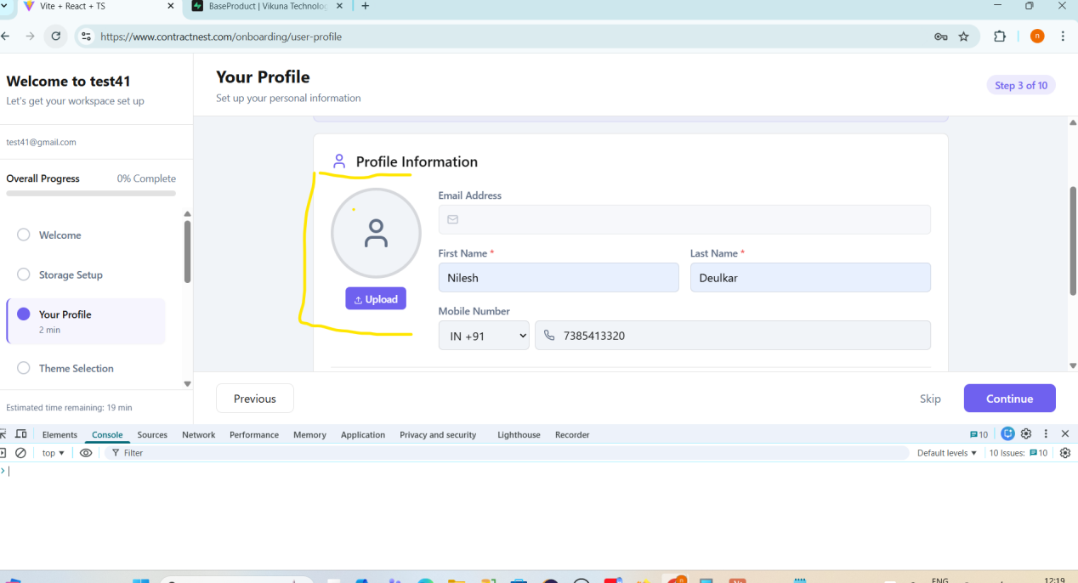

**While updating the application theme or changing the theme mode (e.g., light to dark), the application throws an error and the update does not complete successfully.**

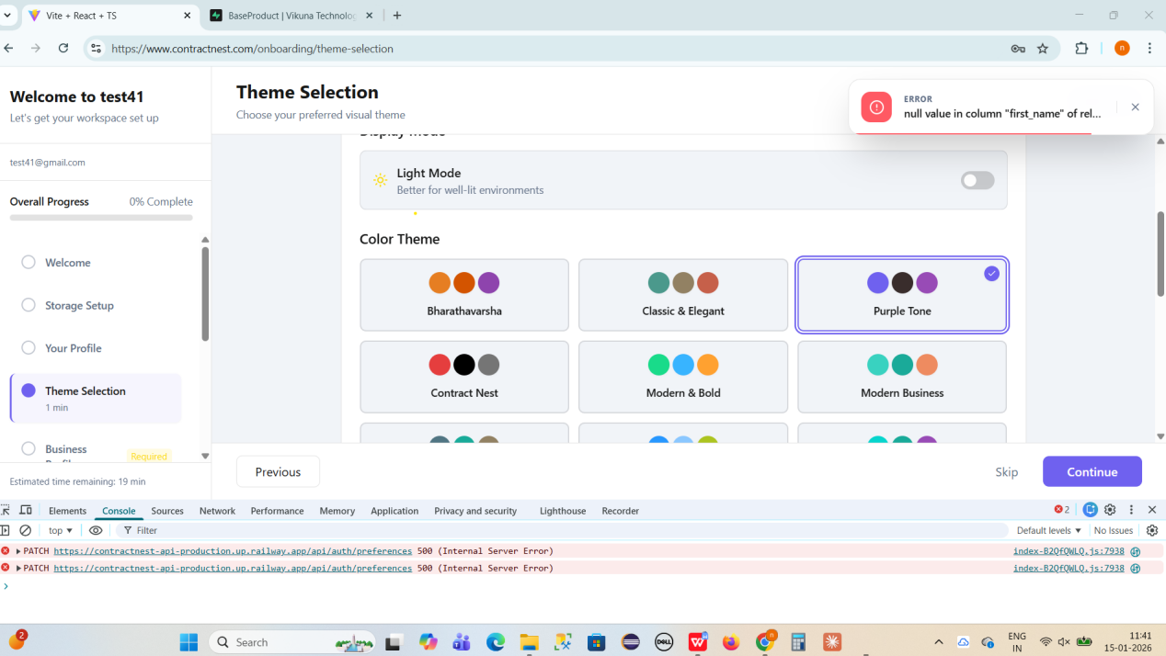

Logs-

index-B2QfQWLQ.js:7938 PATCH https://contractnest-api-production.up.railway.app/api/auth/preferences 500 (Internal Server Error)

(anonymous) @ index-B2QfQWLQ.js:7938

apply @ index-B2QfQWLQ.js:7938

(anonymous) @ index-B2QfQWLQ.js:62

xhr @ index-B2QfQWLQ.js:62

iee @ index-B2QfQWLQ.js:64

Promise.then

_request @ index-B2QfQWLQ.js:65

request @ index-B2QfQWLQ.js:64

(anonymous) @ index-B2QfQWLQ.js:65

(anonymous) @ index-B2QfQWLQ.js:60

tt @ index-B2QfQWLQ.js:7938

d @ index-B2QfQWLQ.js:8868

onClick @ index-B2QfQWLQ.js:8868

WX @ index-B2QfQWLQ.js:48

(anonymous) @ index-B2QfQWLQ.js:48

tY @ index-B2QfQWLQ.js:48

cz @ index-B2QfQWLQ.js:48

kz @ index-B2QfQWLQ.js:49

y0e @ index-B2QfQWLQ.js:49

n @ index-B2QfQWLQ.js:7938

**Skip button is inactive during new tenant onboarding**

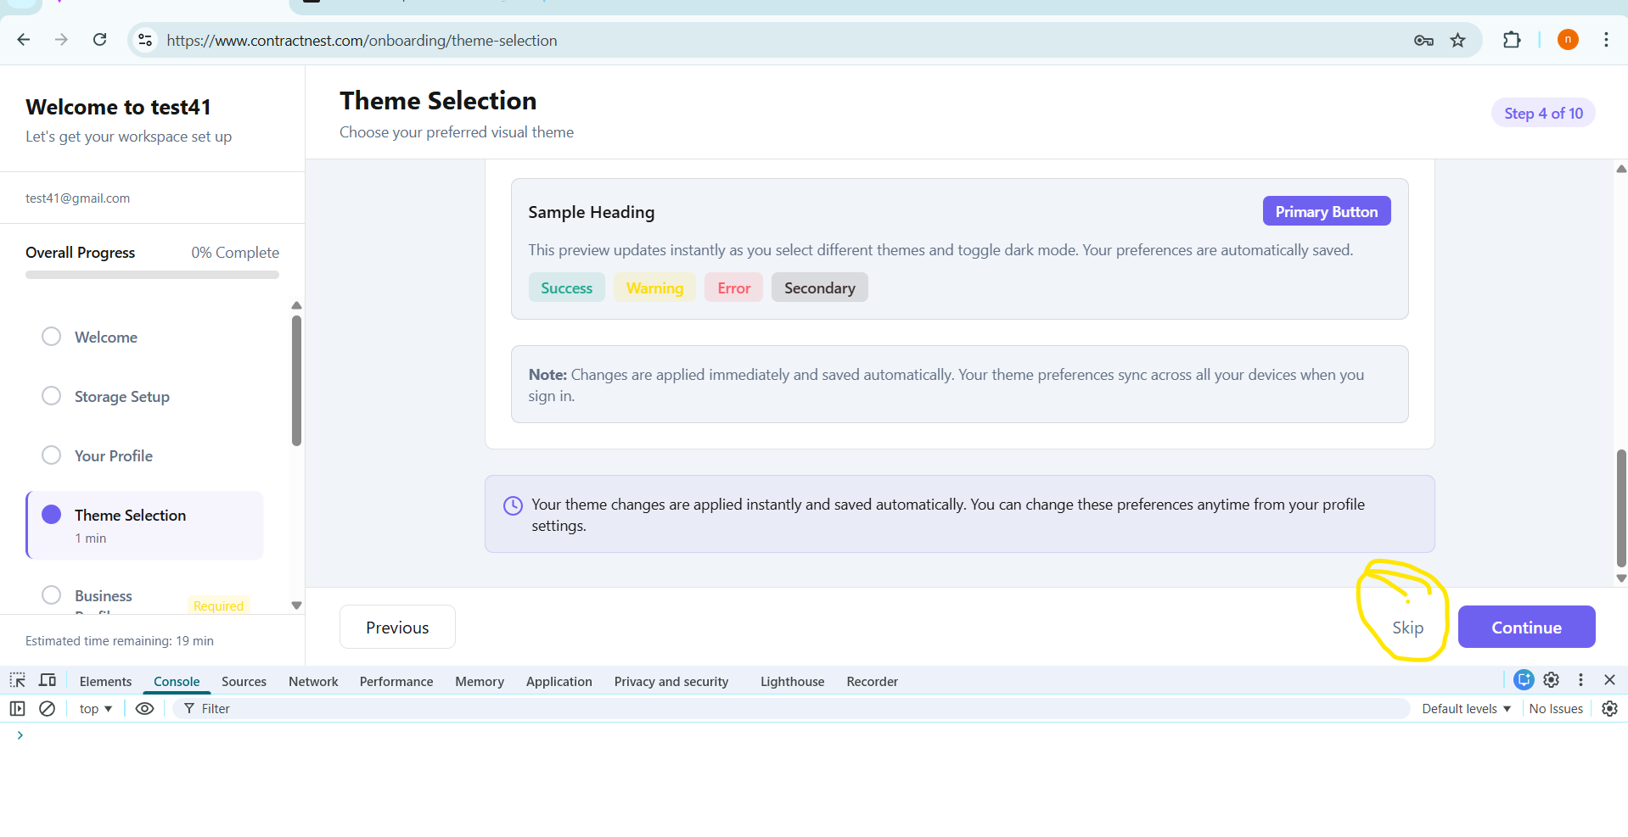

**Issue Description- Application throwing an error while business profile creation**

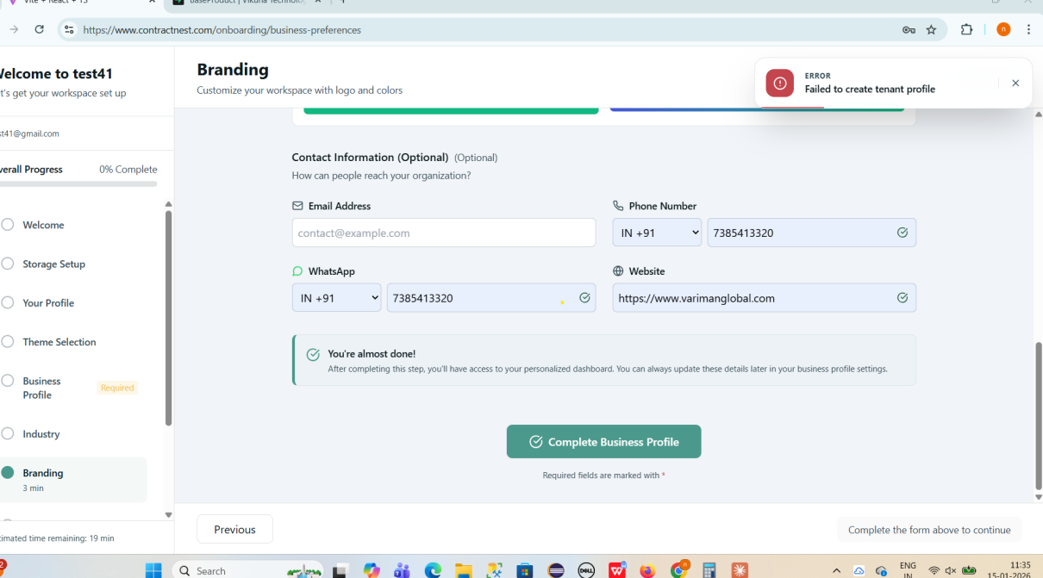

**Settings-Configure-Team Management-Invite User**

**Issue Description--While sending an invite to a user, the **Phone Number** field accepts **more than 10 digits** and also does **not show any error** when fewer than 10 digits are entered. Additionally, the application navigates out of the **Invite User** page unexpectedly.**

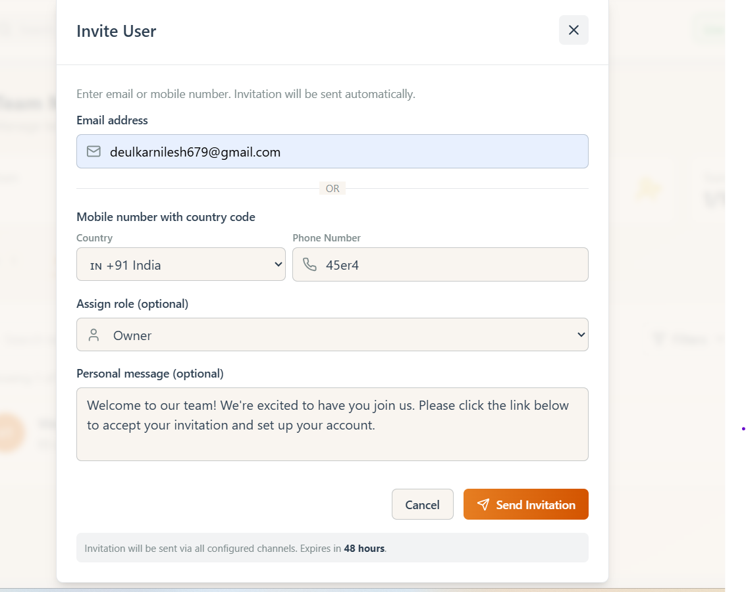

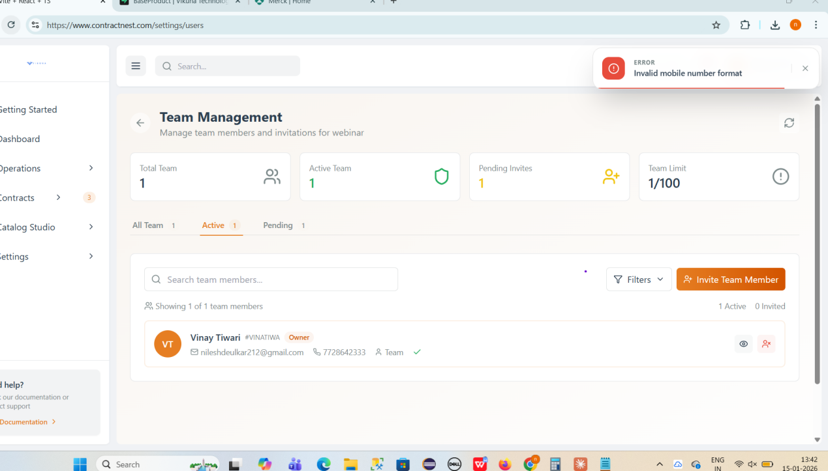

**After sending 2 invites still its showing 0 and Invitation not received on mention email id**

**Emailid- [deulkarnilesh679@gmail.com](mailto:deulkarnilesh679@gmail.com) ( Active)**

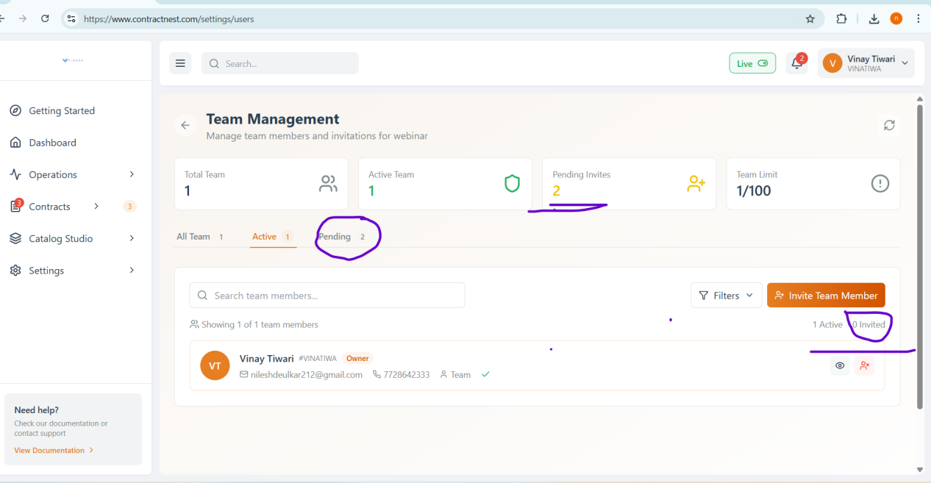

**After sending invite to user, pending count has not been Auto refresh**

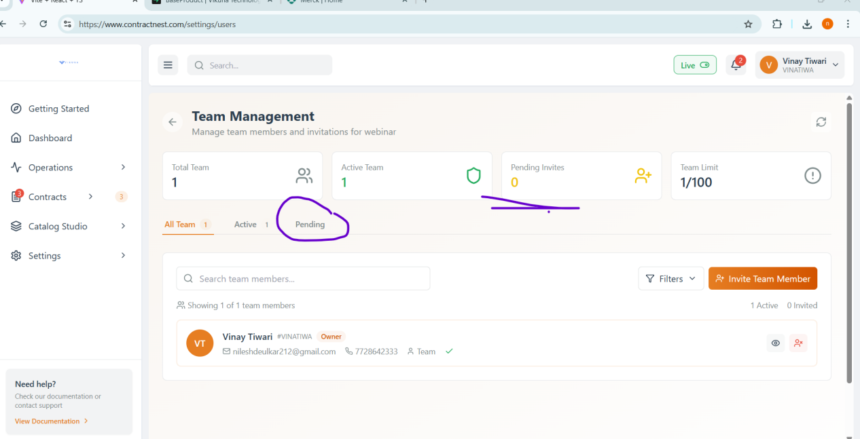

**After click on pending count its updated - Async issue**

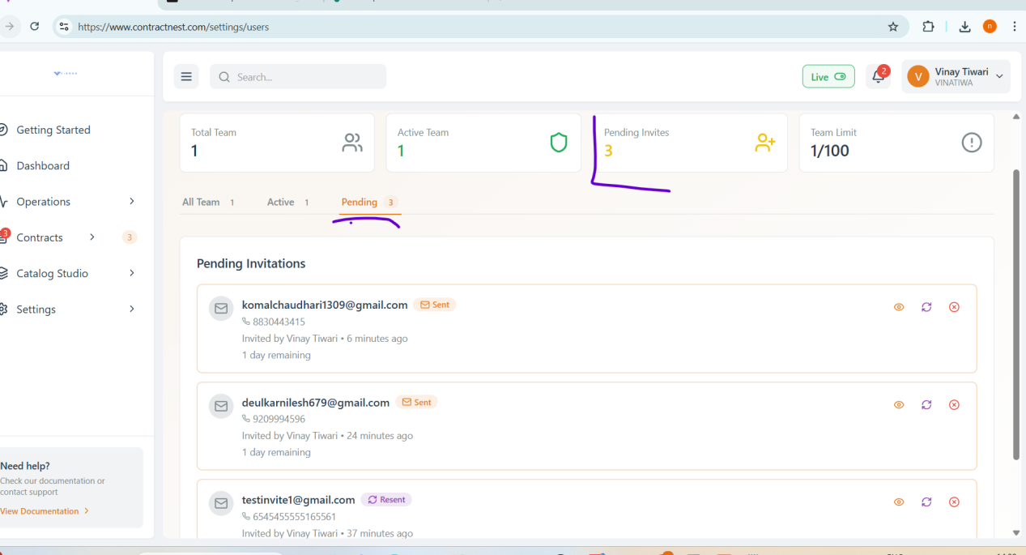

**Invite Sent to ID [-deulkarnilesh679@gmail.com](mailto:-deulkarnilesh679@gmail.com) and accepted it but in active tab wrong user is reflected.**

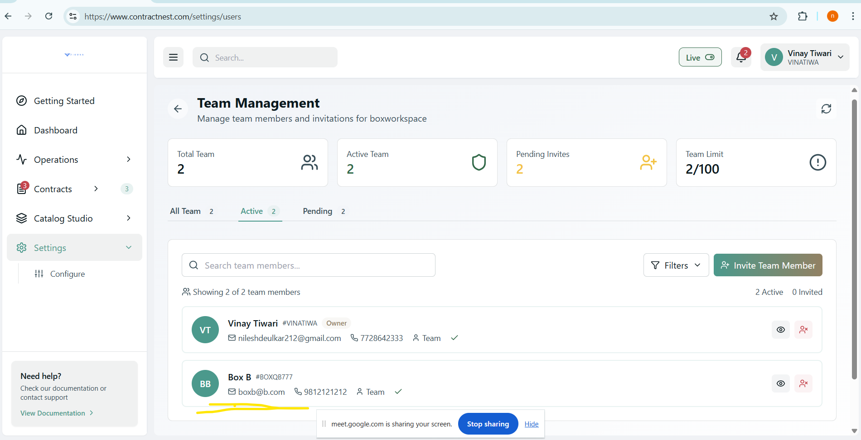

**Contractnest/vikuna logo is not clearly visible**

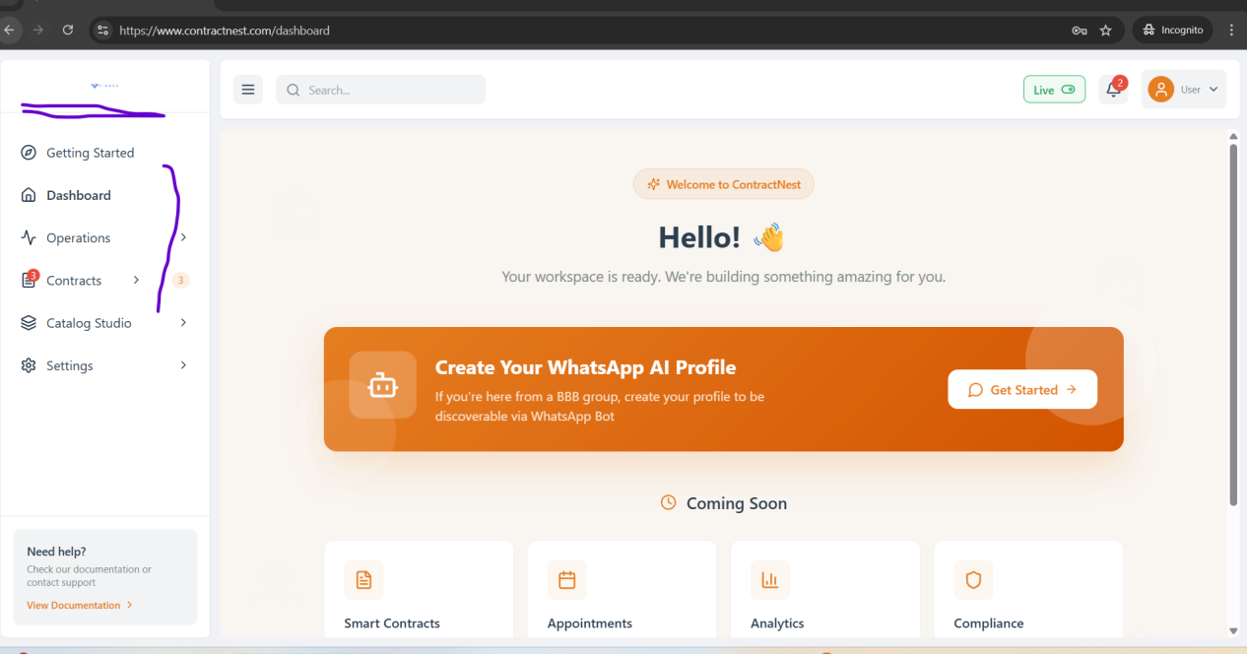

**Module-Contacts**

**Entities help management needs more description about entities,may be it is in development phase-**

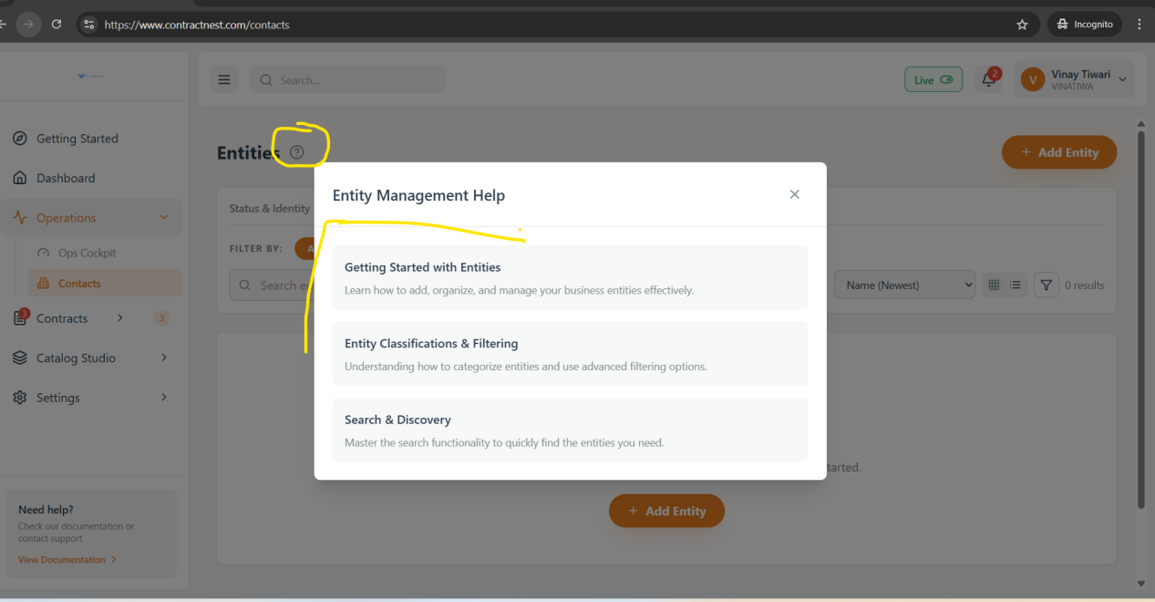

**Issue Description- API request fails with "Error 400 - Bad Request" when attempting to create a Corporate Buyer entity through the Quick Add Entity form and +add another channel as “Phone”**

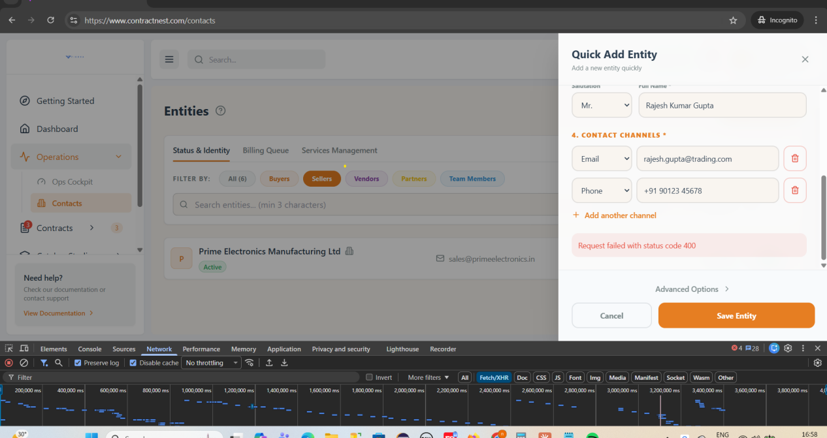

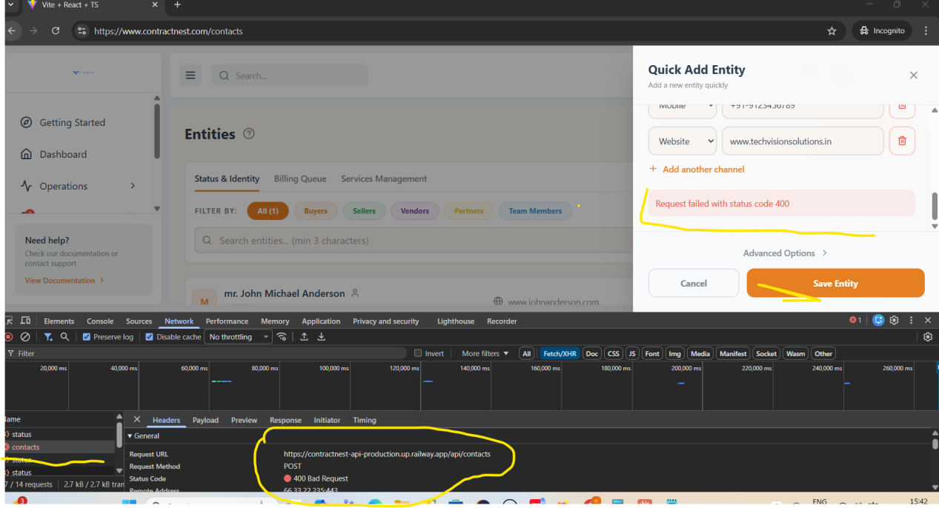

Logs---

POST https://contractnest-api-production.up.railway.app/api/contacts 400 (Bad Request)

(anonymous) @ index-B2QfQWLQ.js:7938

apply @ index-B2QfQWLQ.js:7938

(anonymous) @ index-B2QfQWLQ.js:62

xhr @ index-B2QfQWLQ.js:62

iee @ index-B2QfQWLQ.js:64

Promise.then

_request @ index-B2QfQWLQ.js:65

request @ index-B2QfQWLQ.js:64

(anonymous) @ index-B2QfQWLQ.js:65

(anonymous) @ index-B2QfQWLQ.js:60

mutate @ index-B2QfQWLQ.js:8706

$ @ index-B2QfQWLQ.js:9235

WX @ index-B2QfQWLQ.js:48

(anonymous) @ index-B2QfQWLQ.js:48

tY @ index-B2QfQWLQ.js:48

cz @ index-B2QfQWLQ.js:48

kz @ index-B2QfQWLQ.js:49

y0e @ index-B2QfQWLQ.js:49

n @ index-B2QfQWLQ.js:7938

**Failed to archive contact after clicked on delete button-**

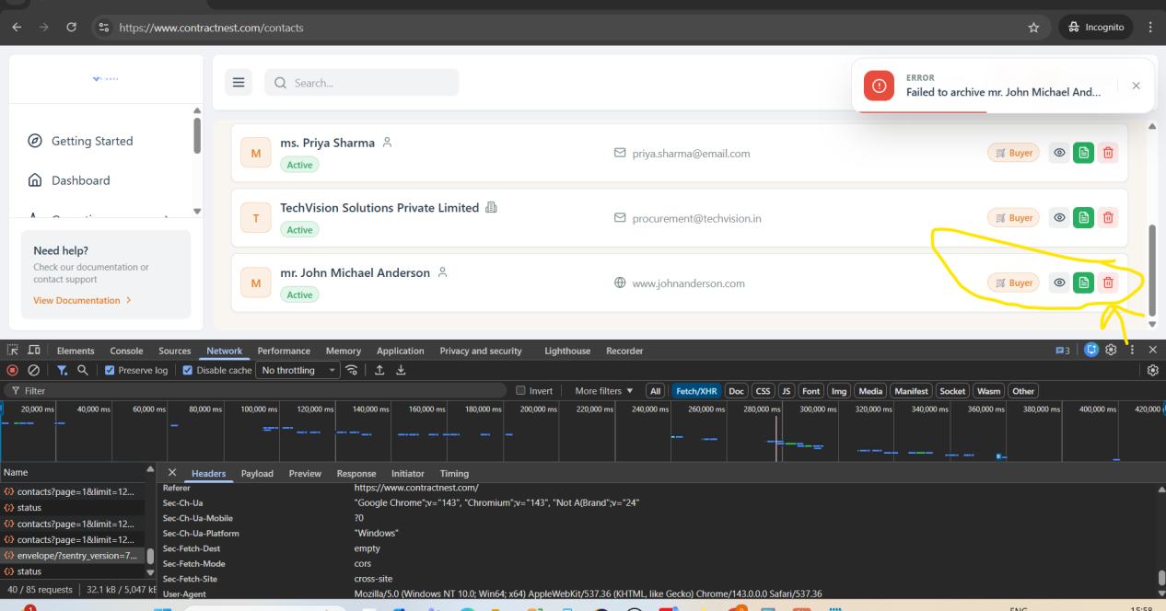

**When we refresh the page its redirecting to the ALL tab it should stay at last selected tab--**

**Added the new seller entity and refresh it then it redirected to the all tab .**

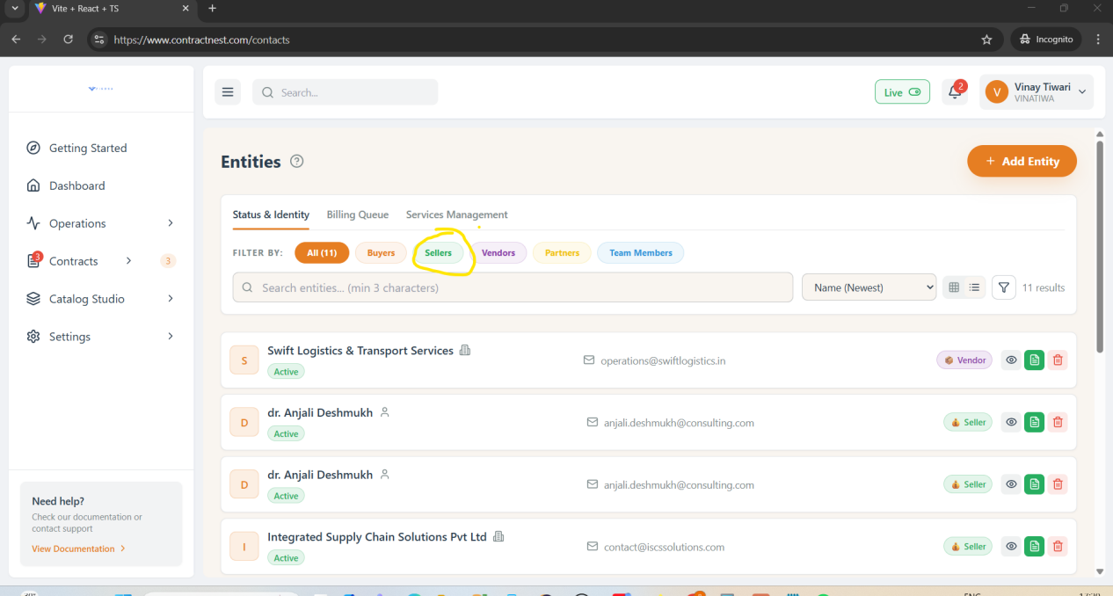

**Need to discuss --Unable to create Entity with Partner + Individual person --**

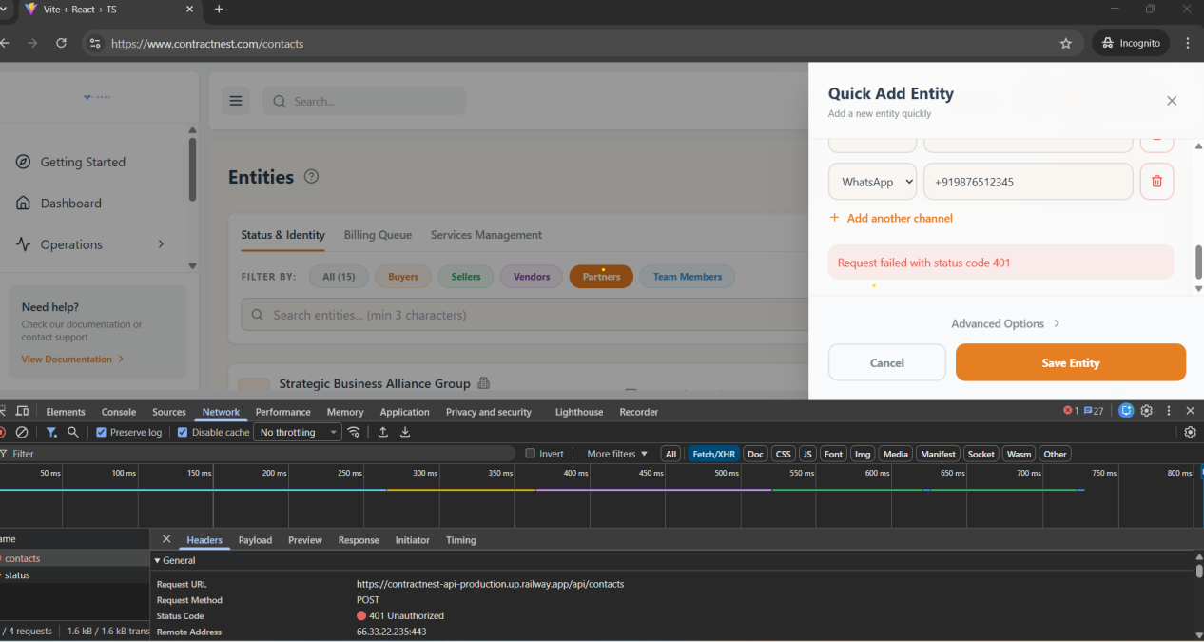

**The filter is not working as expected. Even after filtering by **old date created**, the entries remain in the same order. The most recent entry (**testemailformat**) is still displayed at the top.**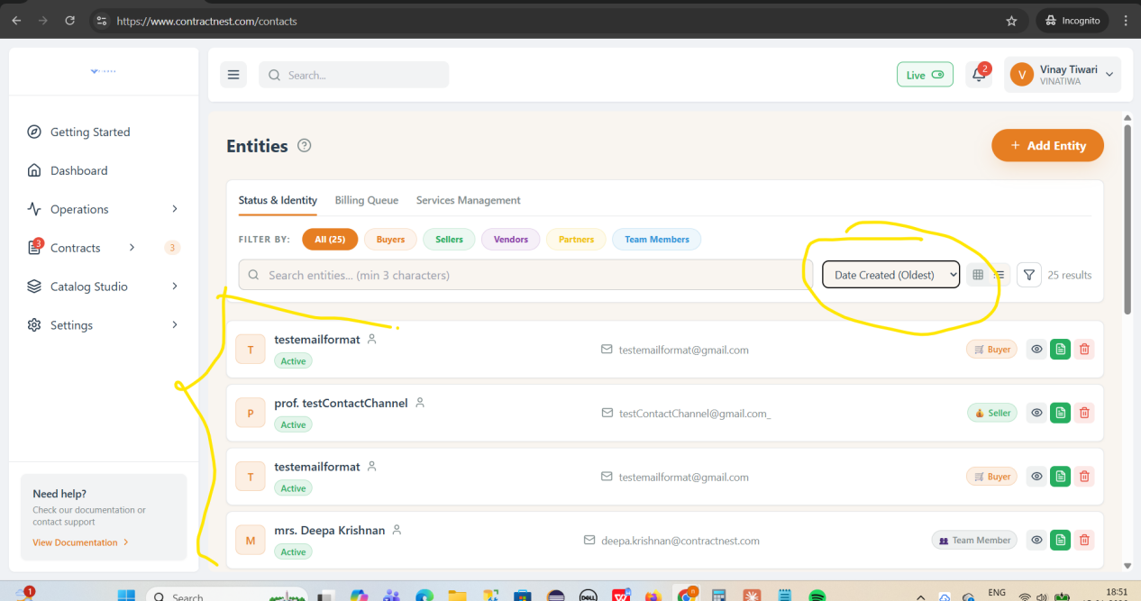

**Mobile Format accepting above 10 digit till14 and Incomplete 8 digit place**

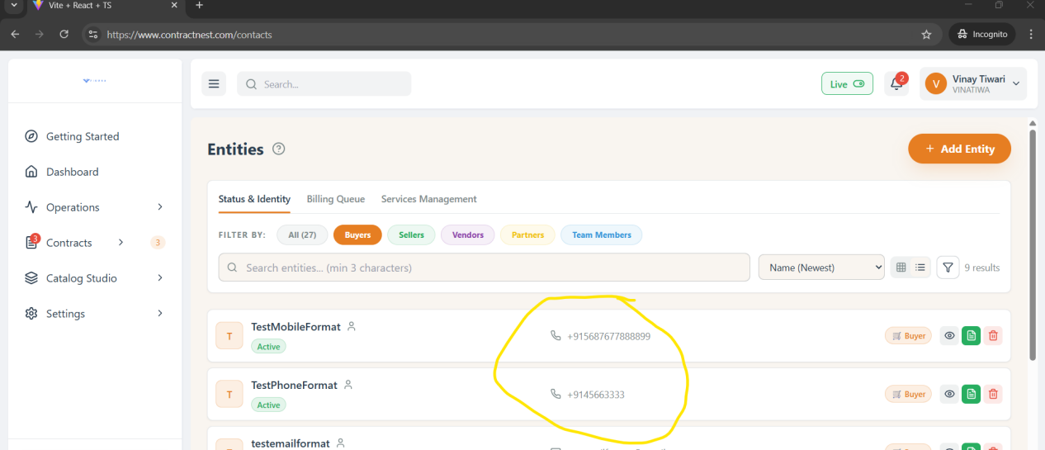

**Name Field is accepting Special Characters---**

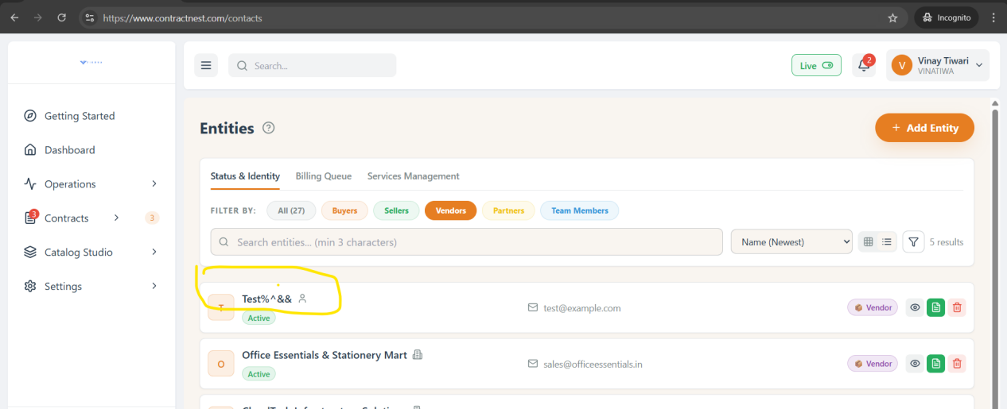

**Duplicate Contact entries allowed in system--**   
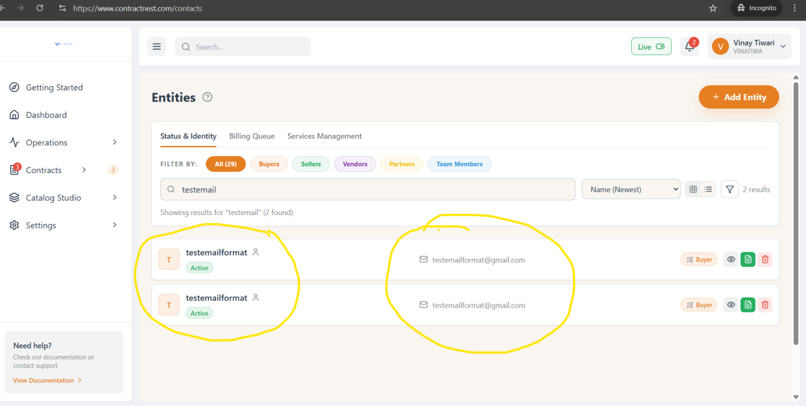

**One user can create with multiple roles like Buyer/seller/partner need to discuss it,..**

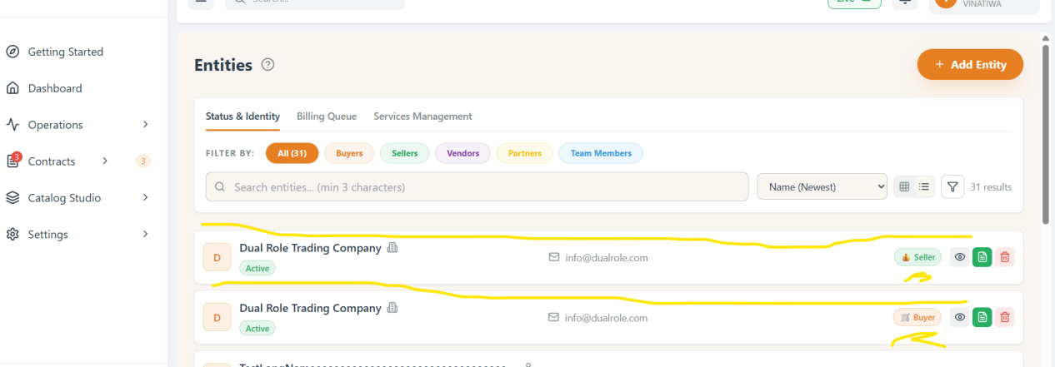

**Settings-Configure-Resource Mnagement-**

**After deleting equipment entry its sequesnce is not auto adjust by skipping deleted entry..**

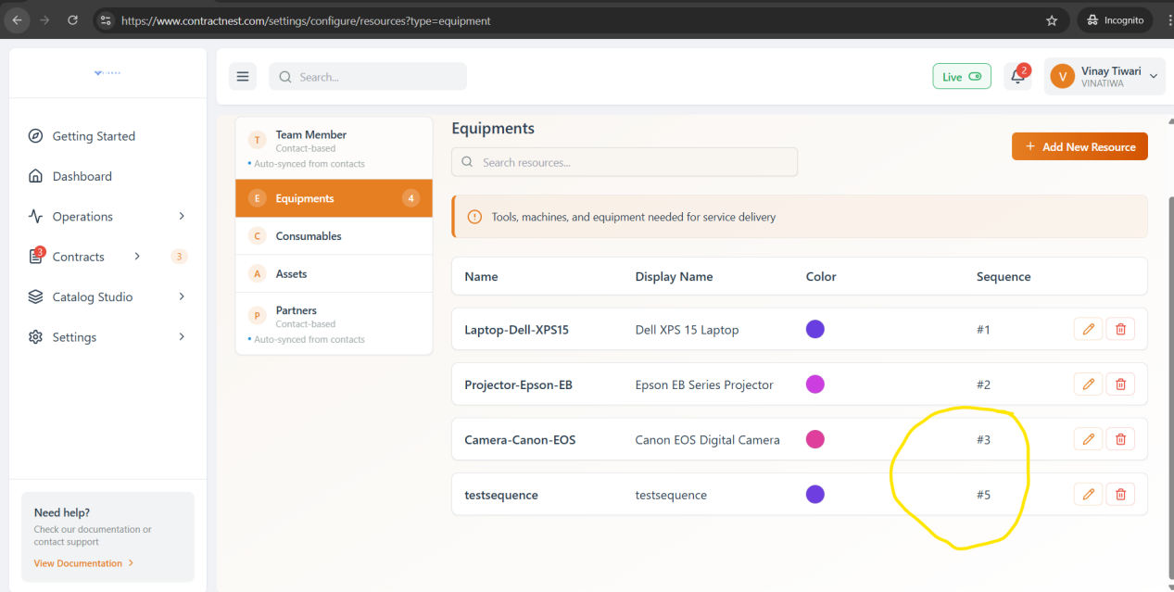

**Settings-Configure--Resource Management**

**After Adding contacts Team Members and Partners these are reflecting in Team member and partner but not appropriate**

**Color and sequence is empty and edit option is not present to mannual update.**

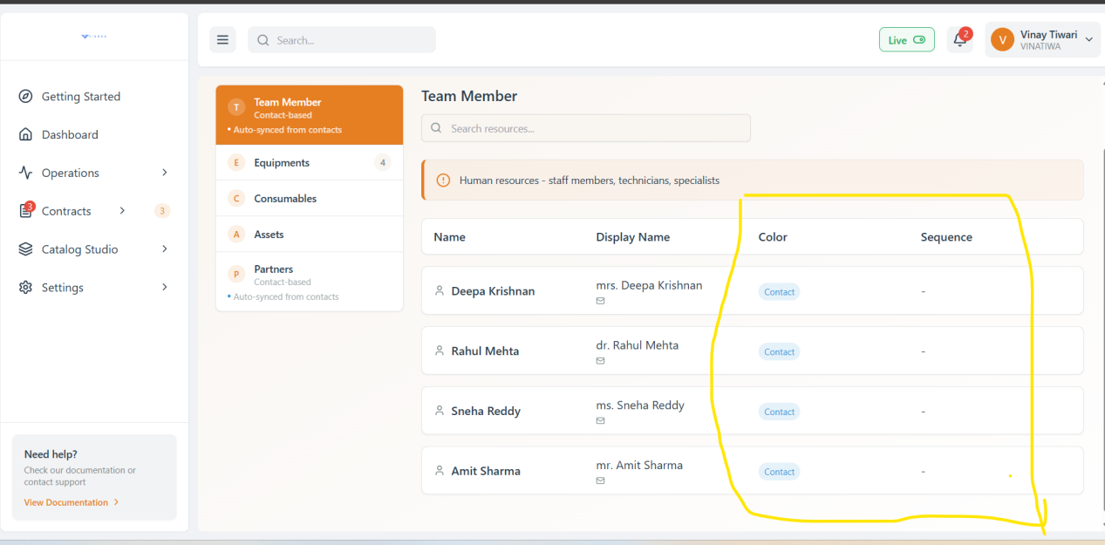

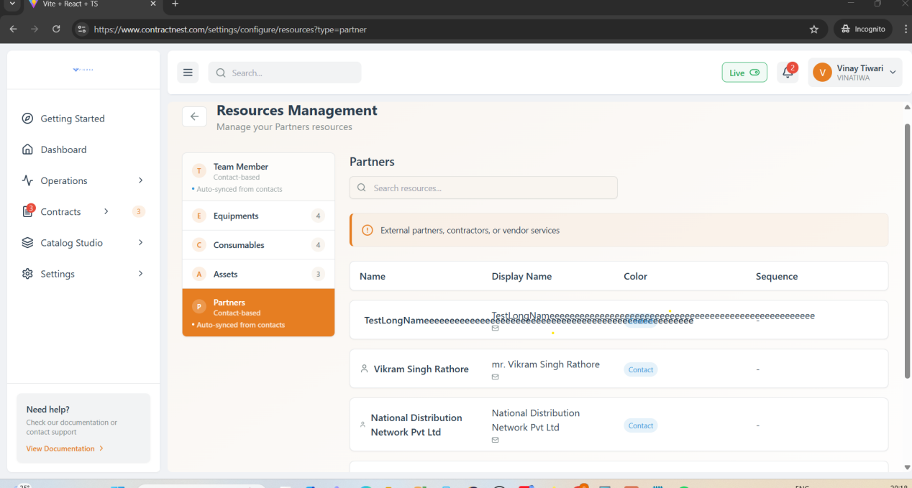

**Setting-Configure-ListOfValues-**

**Showing error while adding new LOV**

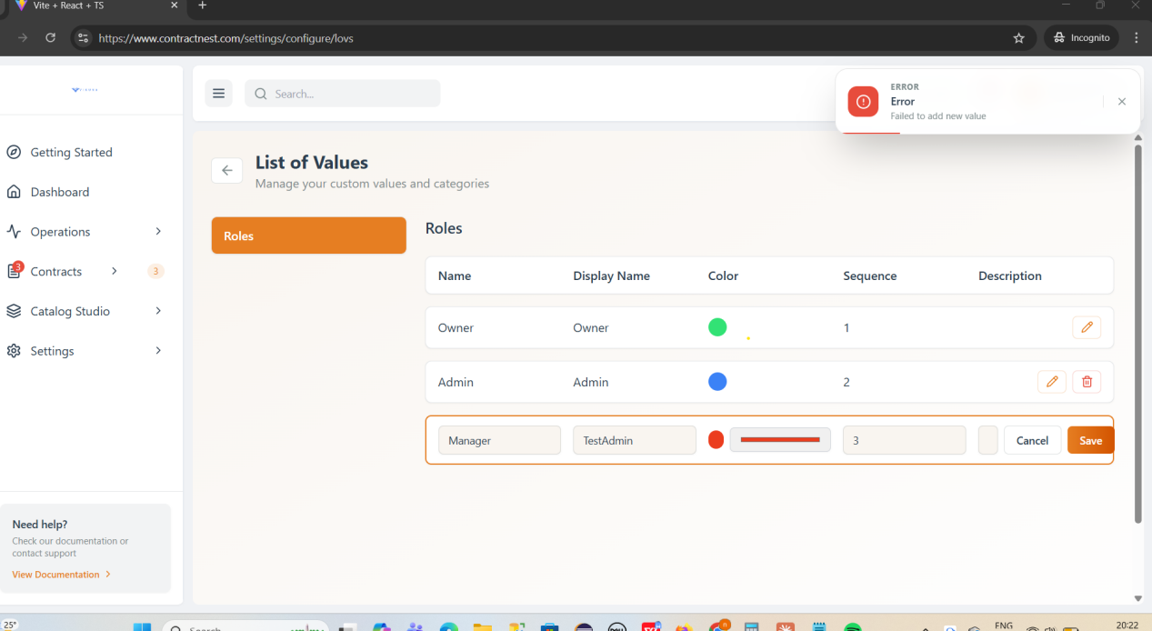

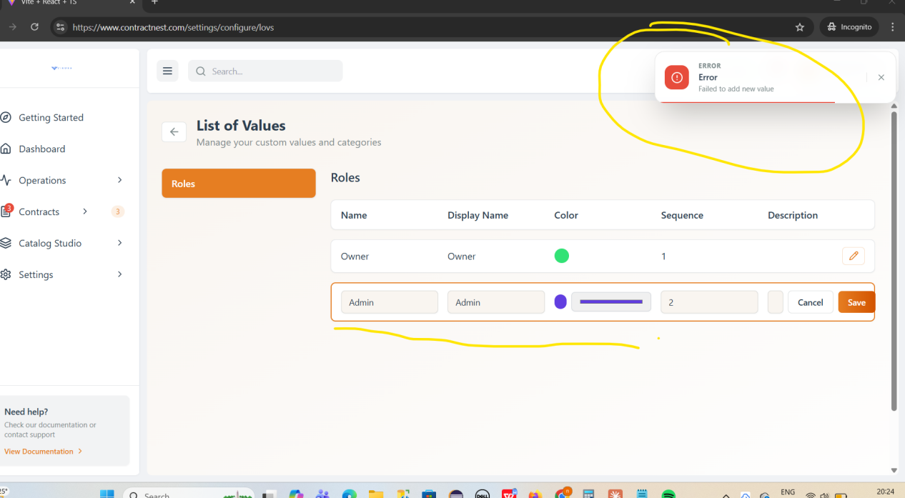

**While adding LOV Description space is showing but it is not editable**

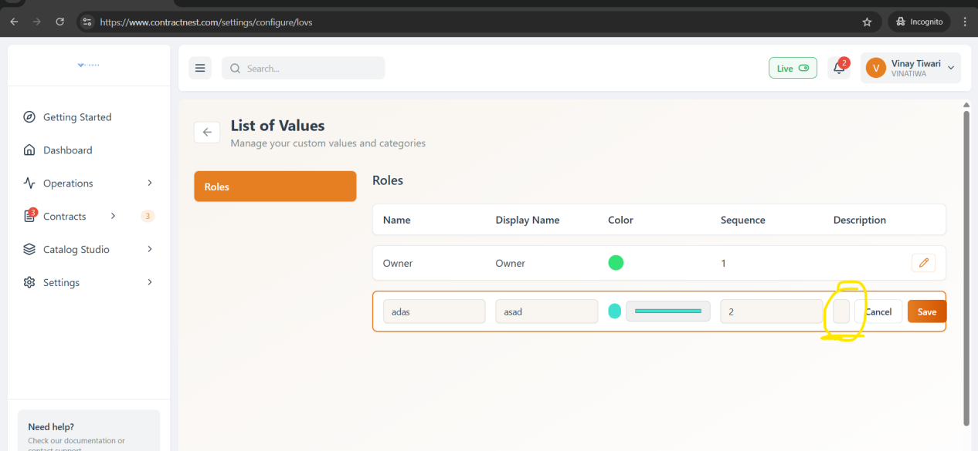

**Settings-Configure-Storage Management**

**After clicking on contact photos, the image is not downloaded and only opens in view mode.**

**Action menu download is not downloaded image**

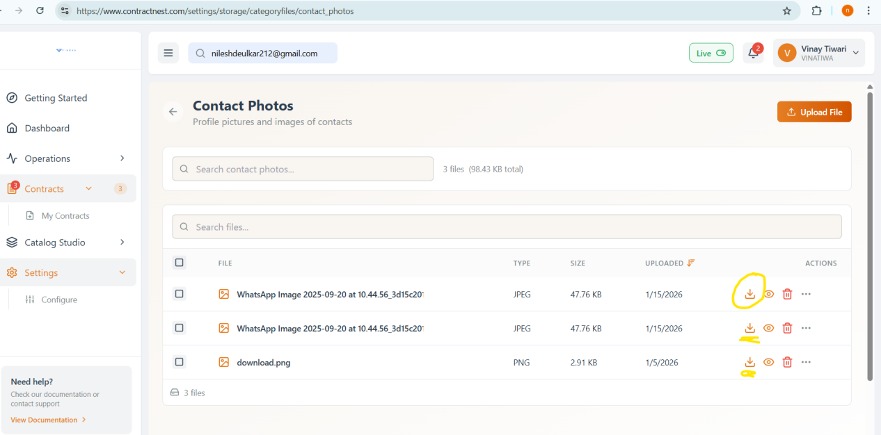

The **Actions menu** is **overlapping** with the **Download, Preview (View), and Delete** options in the contact photos section. Due to this overlap, the options are not displayed clearly and create a UI alignment issue.

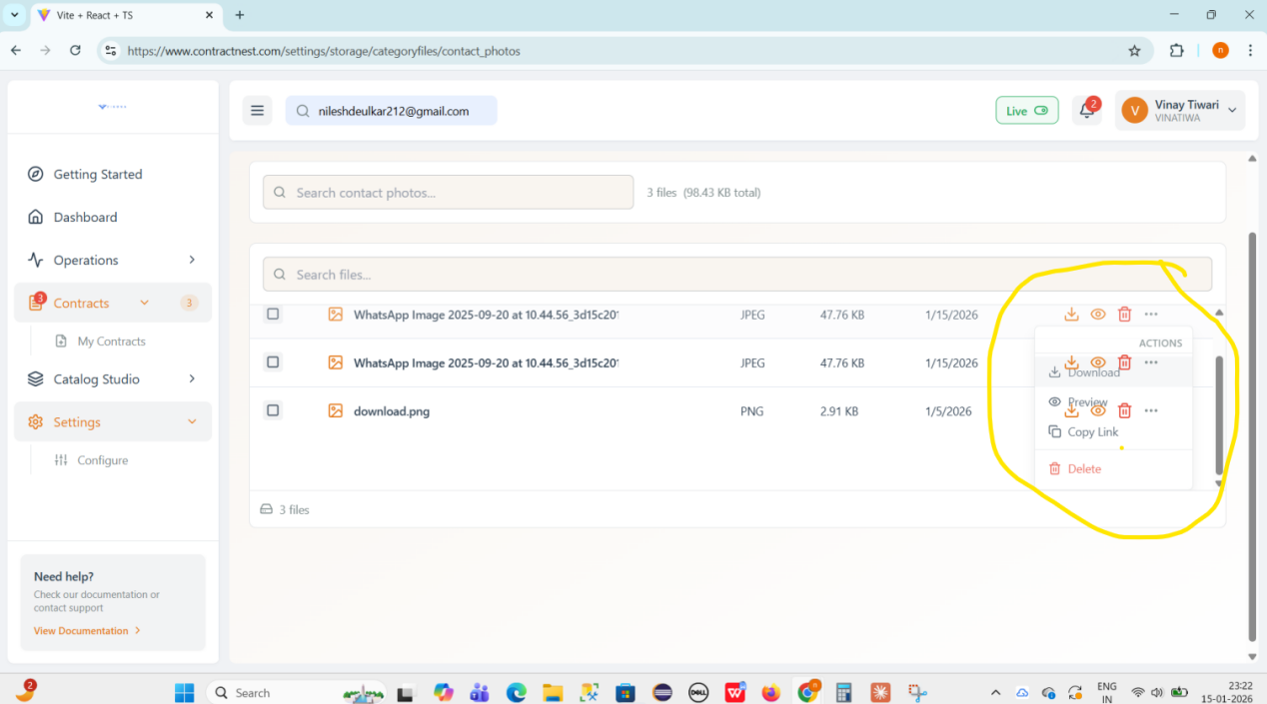

In the **Contact Photos** section, uploading **multiple files/photos** fails and the system throws an **“unexpected end of form”** error.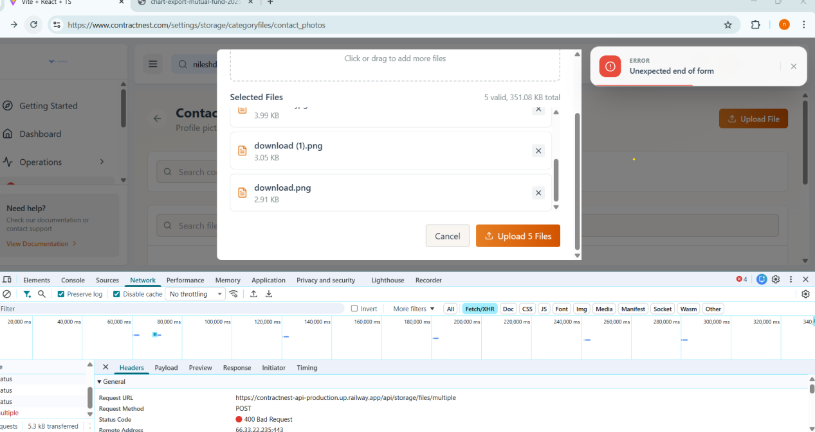

**In storage Mangement while loading conatact photo/contract/documents circular loader is running istead of vani..so need to confirm if it is expected or not ??**

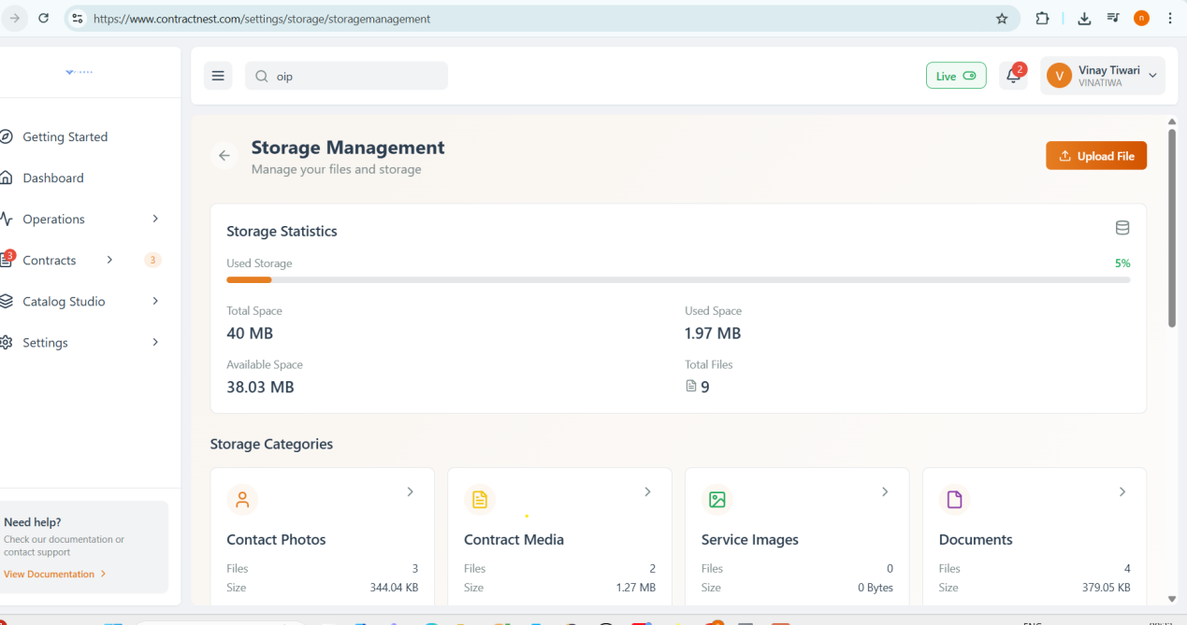

**A UI issue is observed where **additional space** is displayed and can be reduced. There is also a **text and UI alignment issue** in the **Actions** section**.

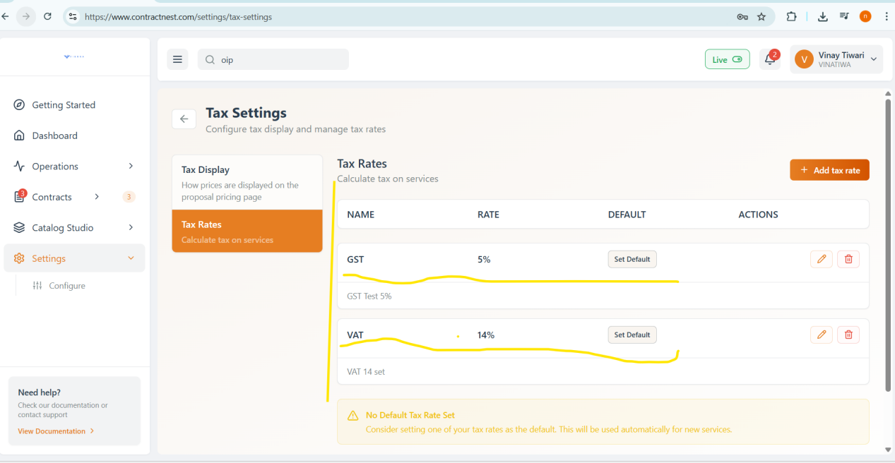

**Settings-configure-Business profile**

**Business profile creation failed**

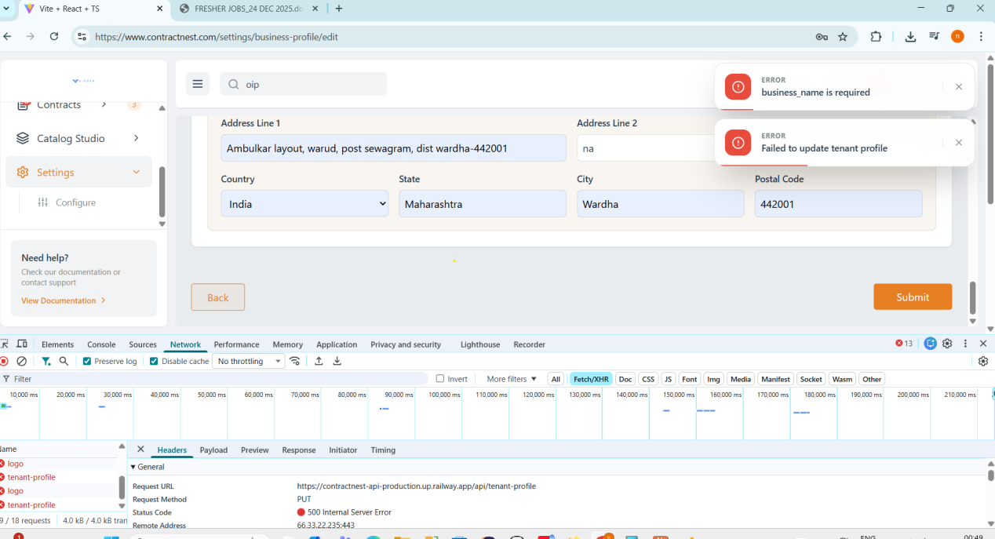

In **Settings → Configure → Sequence Numbers**, after editing the **contact digit** and clicking **Confirm Retest**, the application throws an error.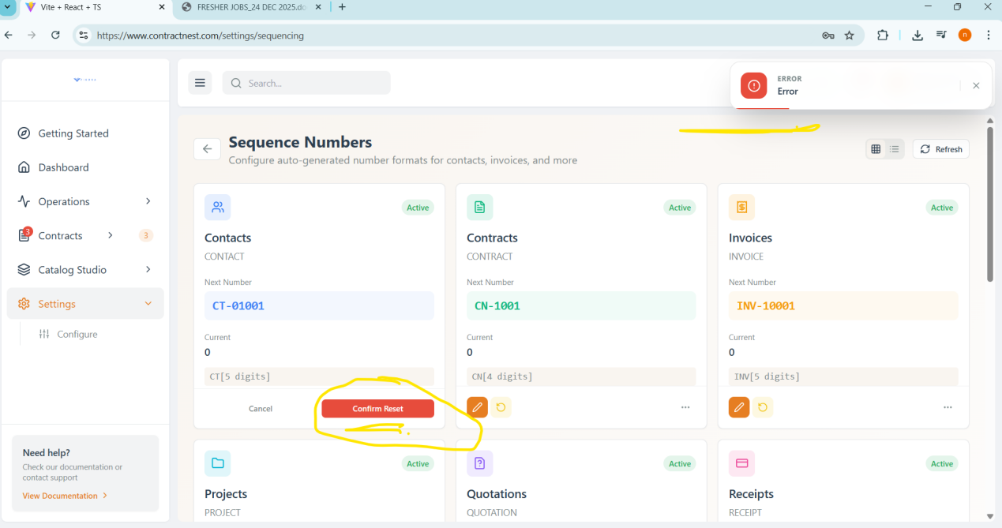

**The **three-dot (more options) menu** is not active and cannot be clicked.**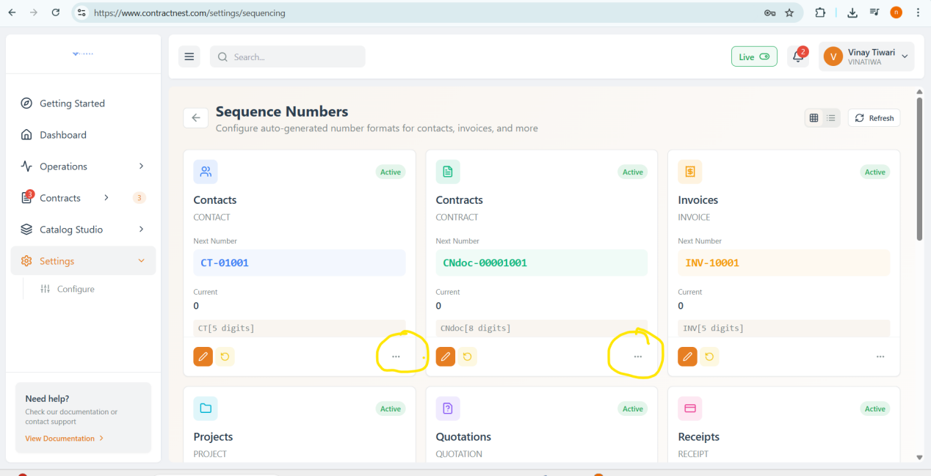

**Points to Discuss-**

**2 Search are there in Storage Categories card--**

**Search at top of the page is not active**

